

Game title

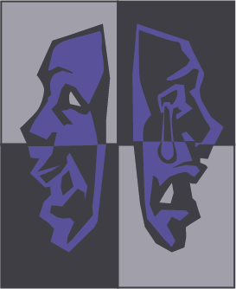

MASKED PRODUCTIONS

**Kahali Griffin, Luke Herron, Sophia Harper, Mark Thomas Gyure, Jacob Stoedter**







Table of Contents

Placeholder……………………………………………………3

Placeholder……………………………………………………4

Placeholder……………………………………………………6

Placeholder……………………………………………………7

Placeholder…………………………………………………...11

Placeholder…………………………………………………...13

Placeholder…………………………………………………...19







?

Team Breakdown

Text text text text text text text text text text text text text text text text text text text text text text Text text text text text text text text text text text text text text text text text text text text

* Text
* Text
* Text



?

Team Breakdown

Section 1: Placeholder

Text text text text text text text text text text text text

text text text text text text text text text text

Text text text text text text text text text text text

text text text text text

Section 2: Placeholder

Text text text text text text text text text text text text

text text text text text text text text text text

Text text text text text text text text text text text

text text text text text

* Text text text text text text
* Text text
* Text text text text text text text text

?

?